**DAILY ONLINE ACTIVITIES SUMMARY**

|  |  |  |  |  |  |  |  |  |
| --- | --- | --- | --- | --- | --- | --- | --- | --- |
| **Date:** | **24-06-2020** | | | | | **Name:** | **Sneha K Bakale** | |
| **Sem & Sec** | **6th B** | | | | | **USN:** | **4al17cs095** | |
| **Online Test Summary** | | | | | | | | |
| **Subject** | | **Java and J2EE and Data Structures with C** | | | | | | |
| **Max. Marks** | | **-** | | **Score** | | | **-** | |
| **Certification Course Summary** | | | | | | | | |
| **Course** | **9:00 am to 11:00 am - Programming in Java and J2EE**  **11:00 am to 1:00pm - Data Structures with C** | | | | | | | |
| **Certificate Provider** | | | **Ms.Shilpa** | | **Duration** | | | **4.0 hours** |
| **Coding Challenges** | | | | | | | | |
| **Problem Statement: Programs given** | | | | | | | | |
| **Status: Completed** | | | | | | | | |
| **Uploaded the report in Github** | | | | | **Yes** | | | |
| **If yes Repository name** | | | | | **Report-**[**https://github.com/Sneha35/OnlineCourse-And-Coding.git**](https://github.com/Sneha35/OnlineCourse-And-Coding.git) | | | |
| **Uploaded the report in slack** | | | | | **Yes** | | | |

Online Test Details: (Attach the snapshot and briefly write the report for the same)

Certification Course Details: (Attach the snapshot and briefly write the report for the same) 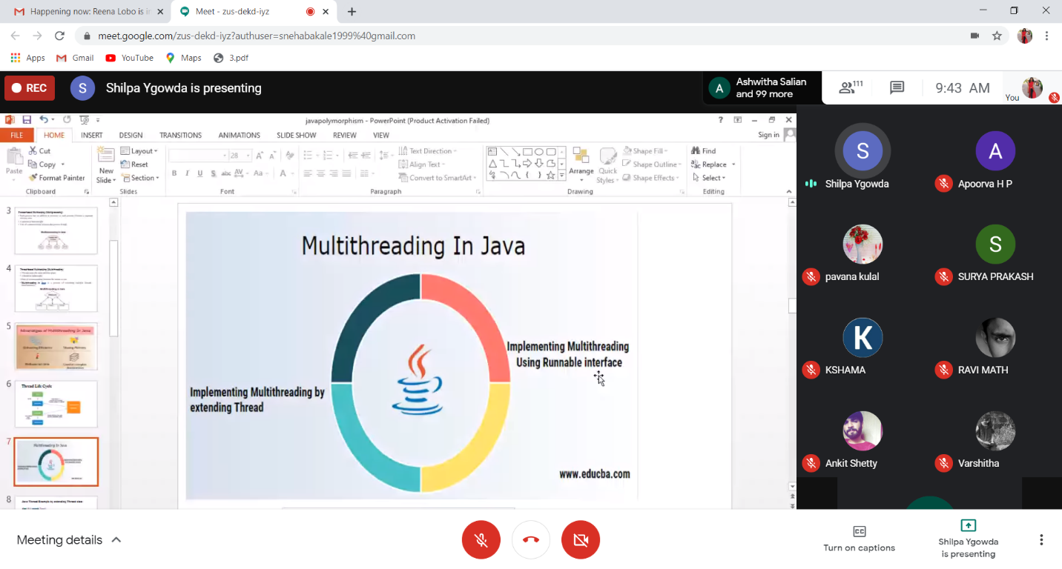

Coding Challenges Details: (Attach the snapshot and briefly write the report for the same)

**1. Create a class named 'Shape' with a method to print "This is This is shape". Then create two other classes named 'Rectangle', 'Circle' inheriting the Shape class, both having a method to print "This is rectangular shape" and "This is circular shape" respectively. Create a subclass 'Square' of 'Rectangle' having a method to print "Square is a rectangle". Now call the method of 'Shape' and 'Rectangle' class by the object of 'Square' class.**

class Shape{

public void print_shape(){

System.out.println("This is shape");

}

}

class Rectangle extends Shape{

public void print_rect(){

System.out.println("This is rectangular shape");

}

}

class Circle extends Shape{

public void print_circle(){

System.out.println("This is circular shape");

}

}

class Square extends Rectangle{

public void print_square(){

System.out.println("Square is a rectangle");

}

}

public class Test{

public static void main(String[] args){

Square sq = new Square();

sq.print_shape();

sq.print_rect();

}

}

**Output:**

